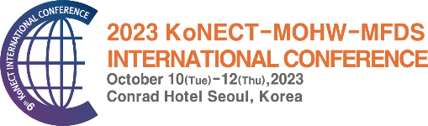 | 2023 KoNECT-MOHW-MFDS  INTERNATIONAL CONFERENCE

Application Form for Sponsorship Opportunities

Please submit the Application Form by E-mail info-kic@konect.or.kr.
For further details, please contact the Exhibition Secretariat.

Applicant Information
Company Information
Company Name (ENGLISH): | Company Name (KOREAN):
Address:
Country: | Zip Code:
Contact Person’s Name: | Position:
Department: | Telephone:
Fax.: | Mobile Phone:
E-mail: | Website:
Business Registration Number:

Sponsorship Option
Category |  | Price(KRW)
Individual  Advertising | □ Logo on KIC newsletter | 3,000,000(USD 2,600)
 | □ Logo on KIC website | 2,000,000(USD 1,800)
 | □ Logo on photo wall | 2,000,000(USD 1,800)
 | □ Logo on event banner | 2,000,000(USD 1,800)
 | □ Full page Ad in program book | 1,000,000(USD 1,000)
 | Sponsor Session  (30 minutes presentation/Limit 9) | □ Exhibitor | 1,000,000(USD 1,000)
 |  | □ Non-Exhibitor | 2,000,000(USD 1,800)
Total Fee (KRW)
※ Refund : When canceling the sponsorship application, you must submit the cancellation document in writing.
- This Sponsorship contract become effective upon submission of the documents to the KIC Secretariat.
- Until September 8th : Full refund (excluding remittance fee)
- From September 9th : No refund

Date (DD/MM/YYYY ) COMPANY NAME (SIGNATURE)

